**SYSTEM MANUAL**

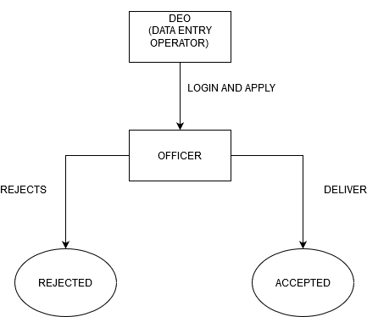

1. **LOGIN WITH DEFINER LOGIN AND SELECT CREATE NEW SERVICE.**

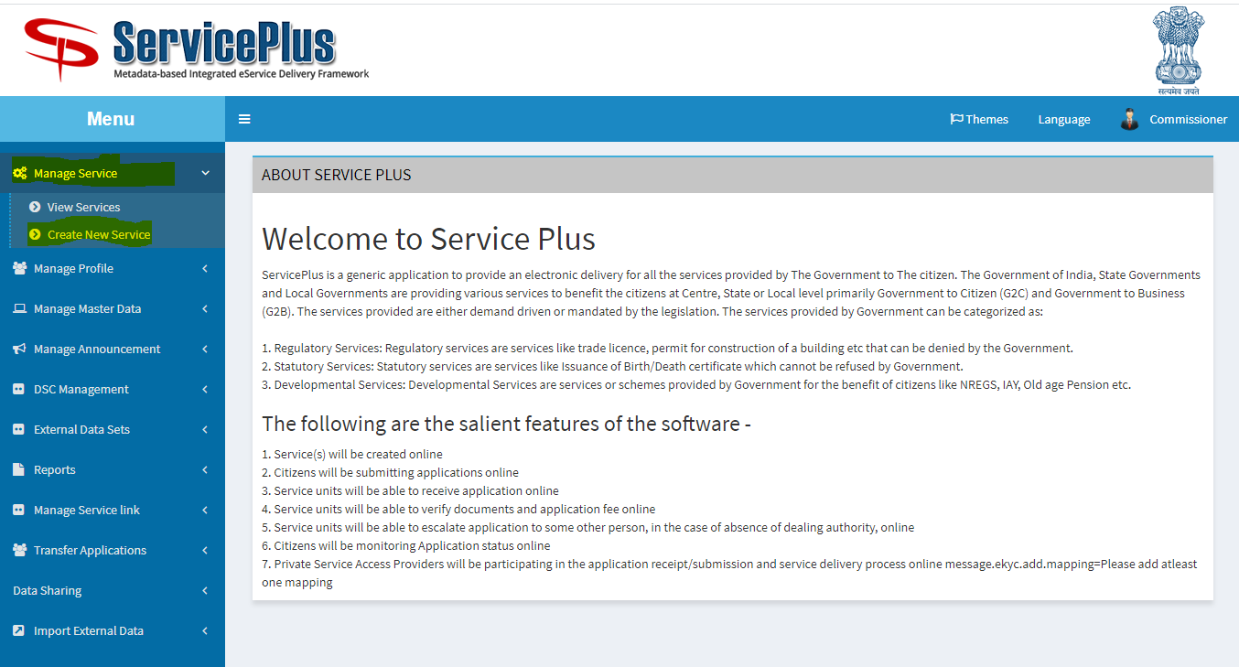

1. **SELECT DEFINITION AND FILL ALL DETAILS.**

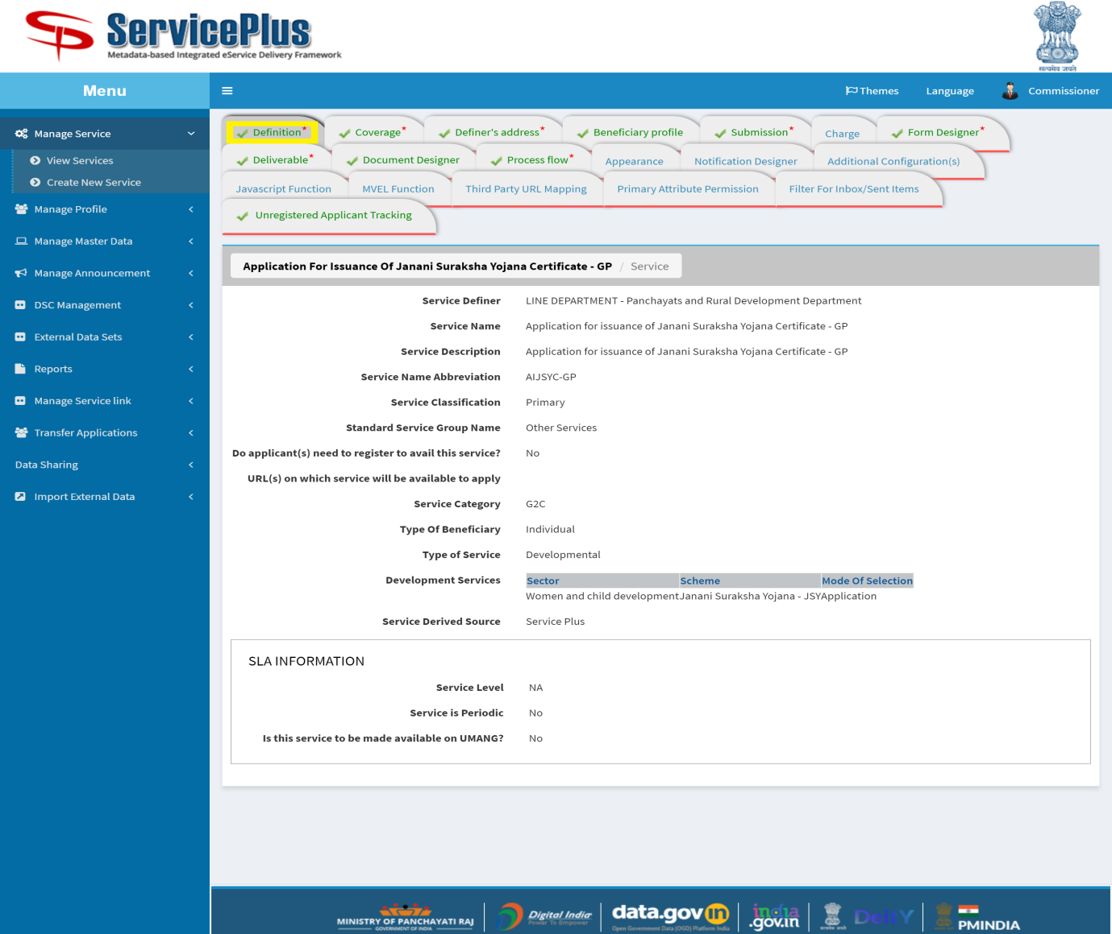

1. **SELECT COVERAGE AND SELECT THE LIST OF SERVICE UNITS.**

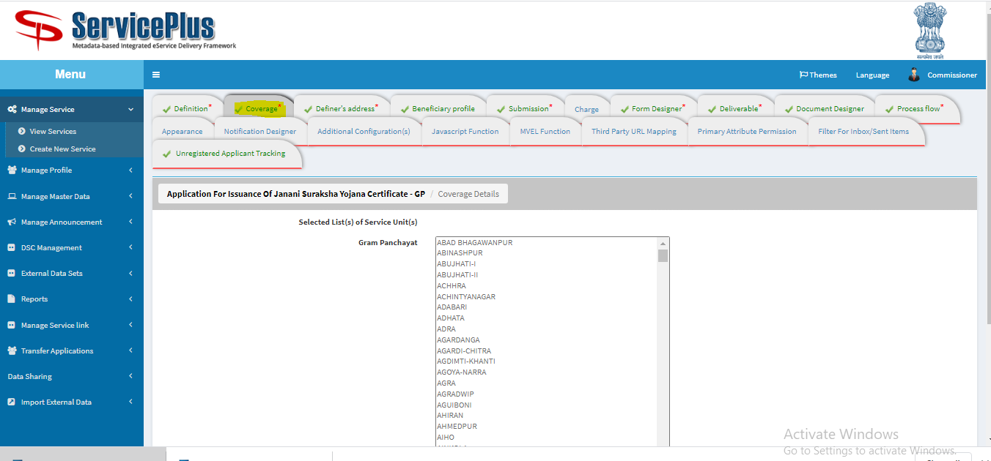

1. **FILL DEFINER’S ADDRESS.**

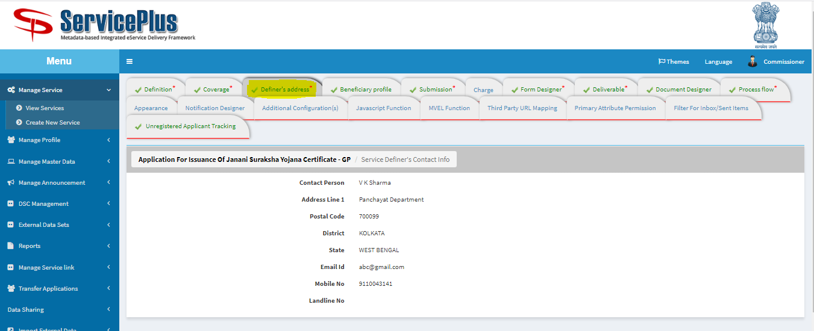

1. **BENEFICIARY PROFILE FOR WHO CAN APPLY.**

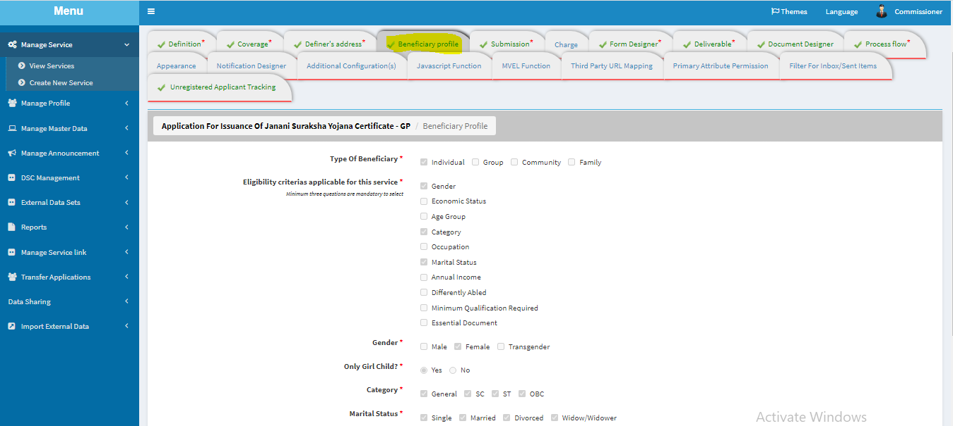

1. **SUBMISSION**

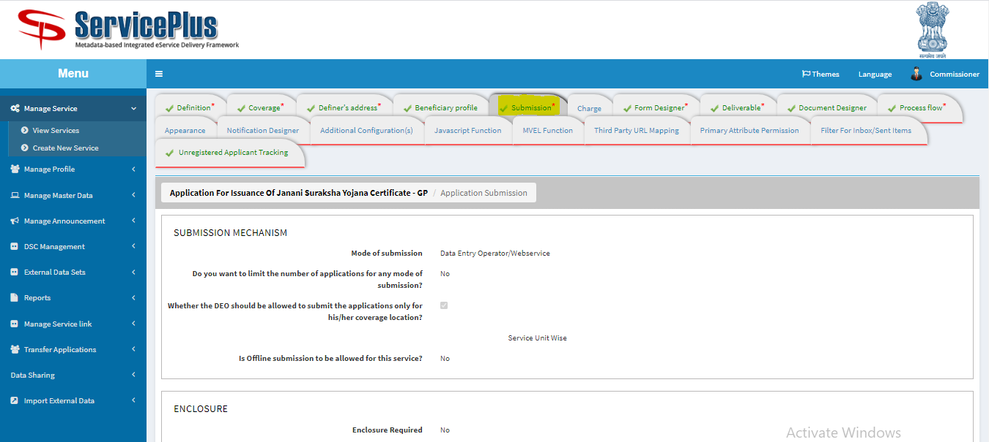

1. **FORM DESIGNER: HERE NEW TEMPLATE FOR FORM CAN BE DESIGNED, MODIFIED OR PREVIEWED.**

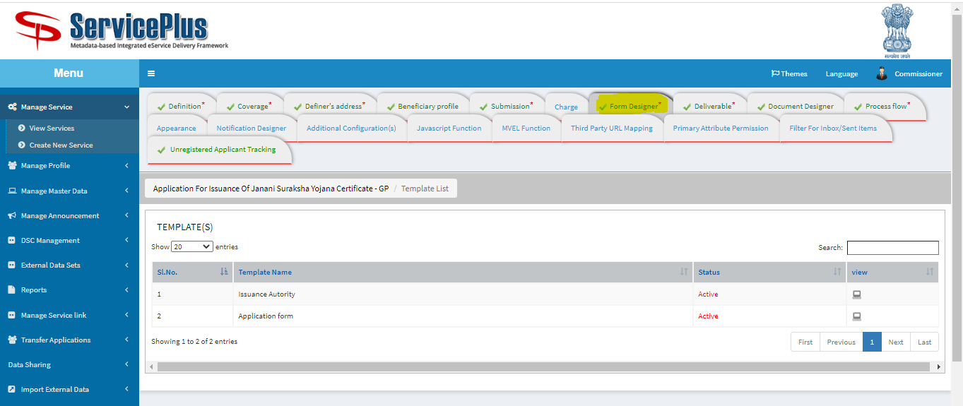

**APPLICATION FORM CONFIGURATION.**

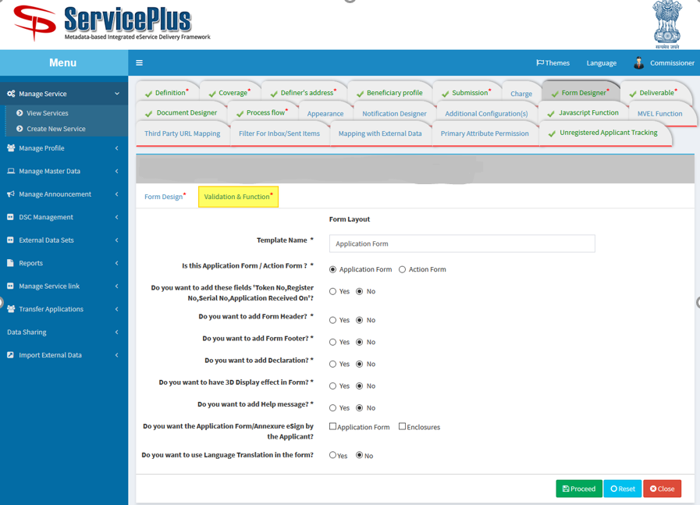

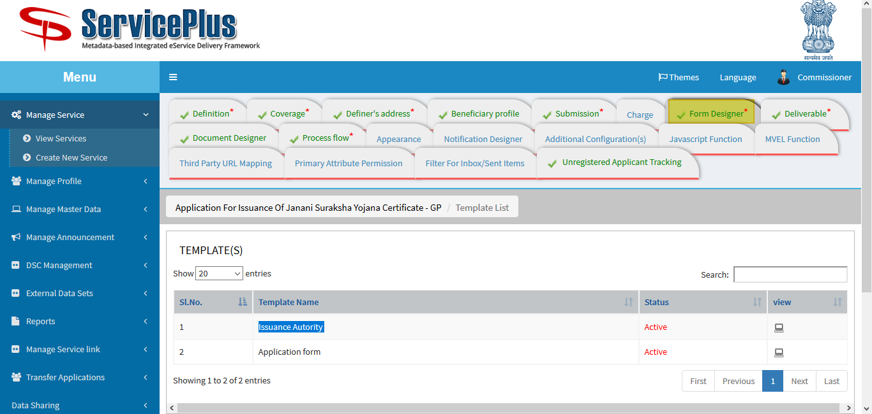

**Application form**

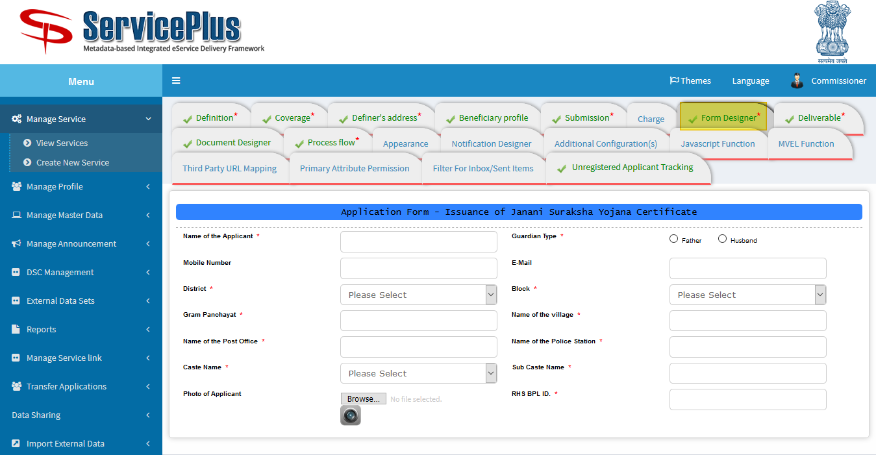

**Issuance Authority**

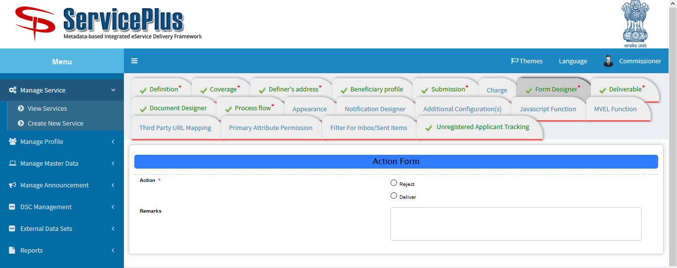

1. **DELIVERABLE: HERE CONFIGURATION IS DONE FOR APPLICATION WHEN IT’S DELIVERED.**

**CERTIFICATES AND BARCODE COULD BE SELECTED TO BE IMPRINTED ON CERTIFICATES.**

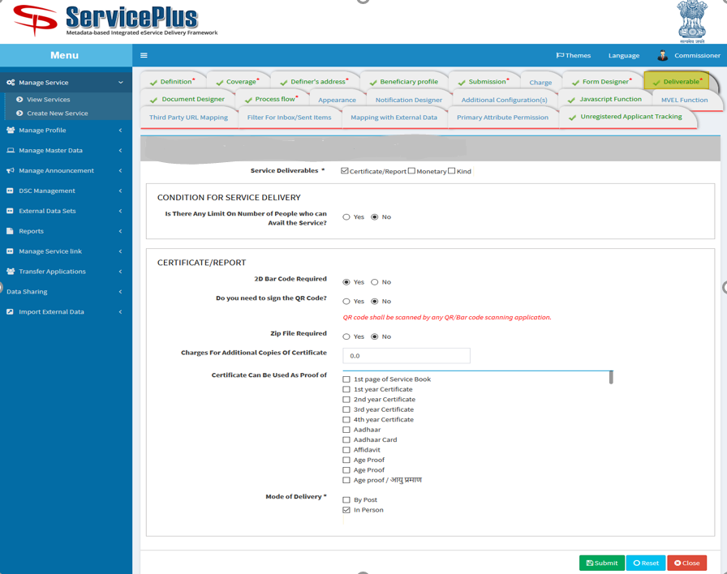

1. **DOCUMENT DESIGNER: DOCUMENT CAN BE DESIGNED HERE.**

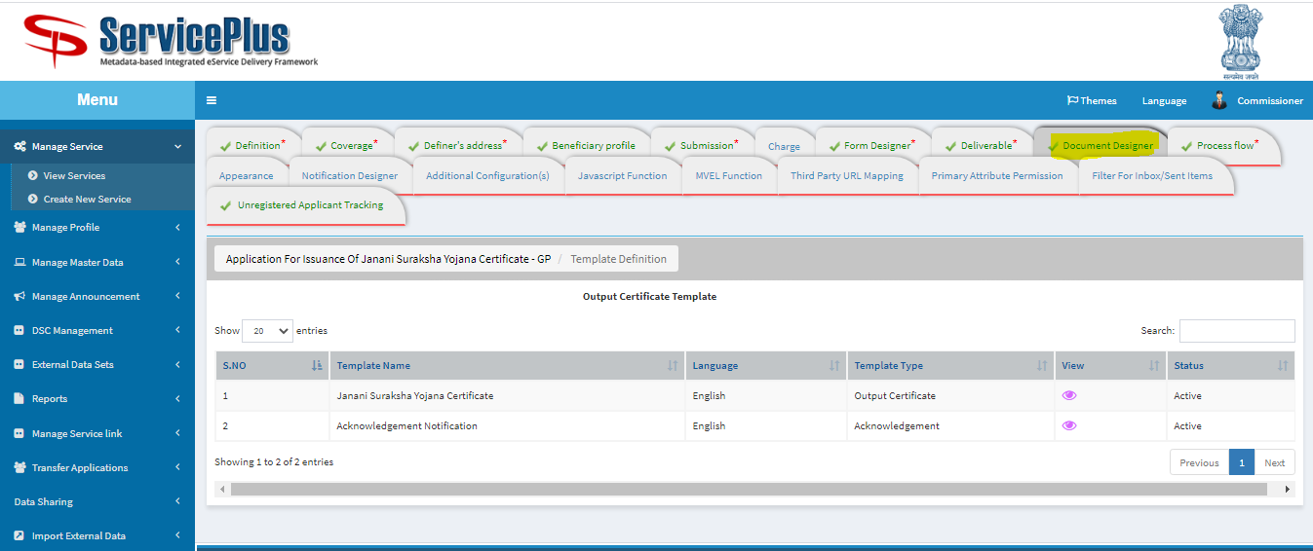

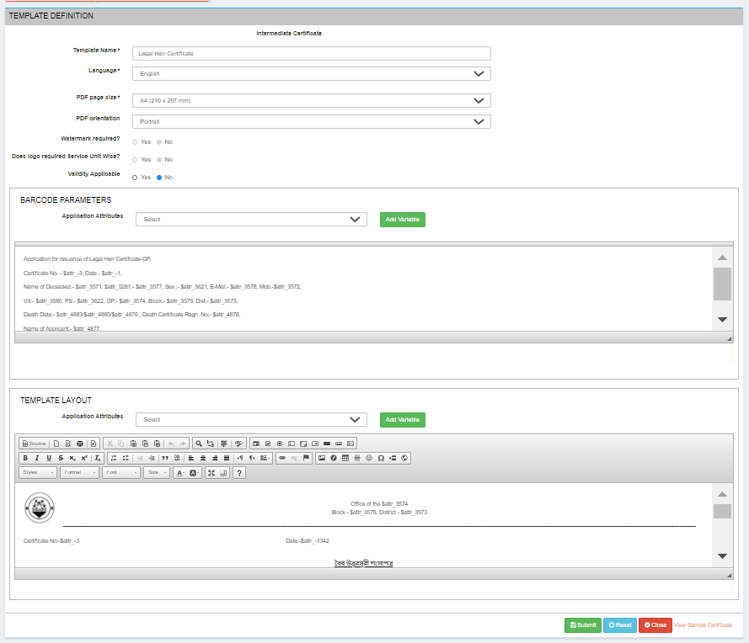

1. **PROCESS FLOW: ASSIGN DEPARTMENT/DESIGNATON FOR DEPARTMENT PURPOSE WHO IS GOING TO TAKE ACTION.**

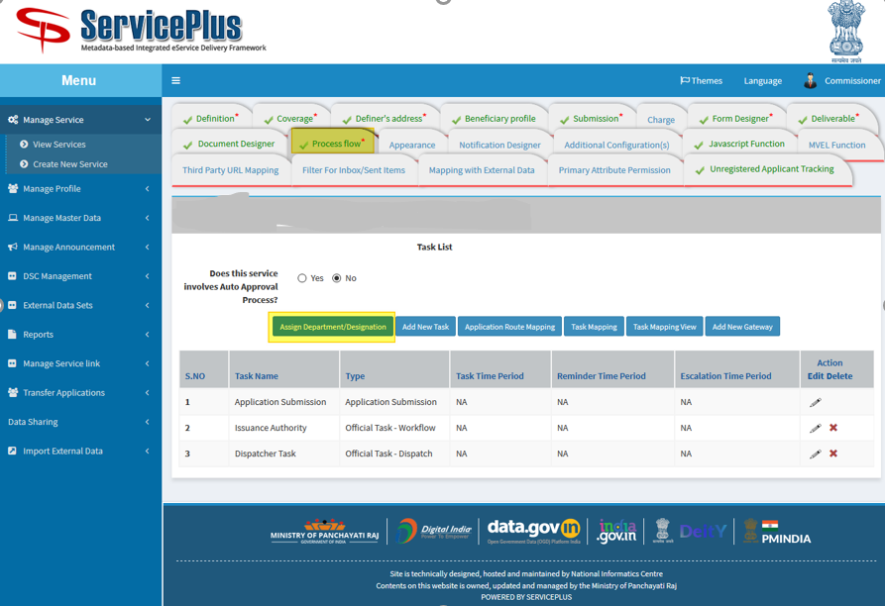

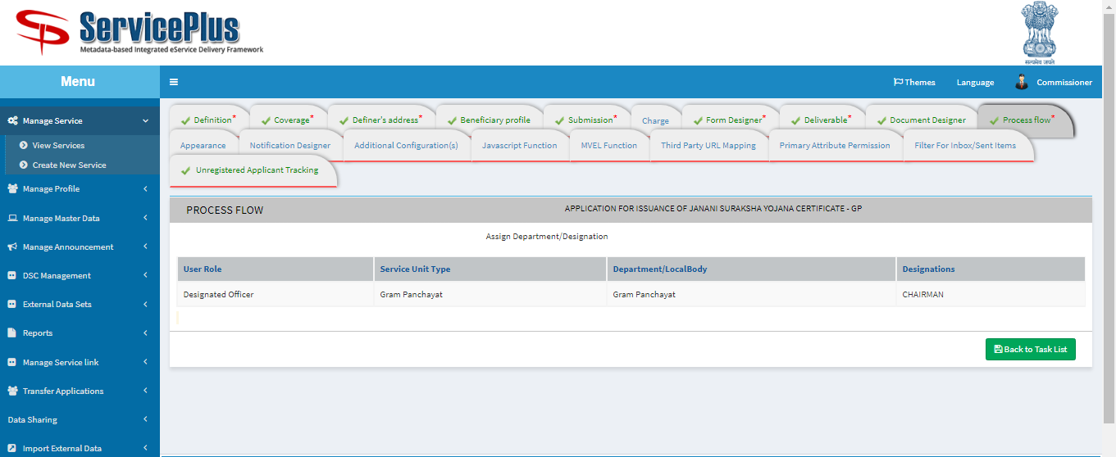

1. **ADD NEW TASK: NEW TASK CAN BE ADDED LIKE THIS WAY.**

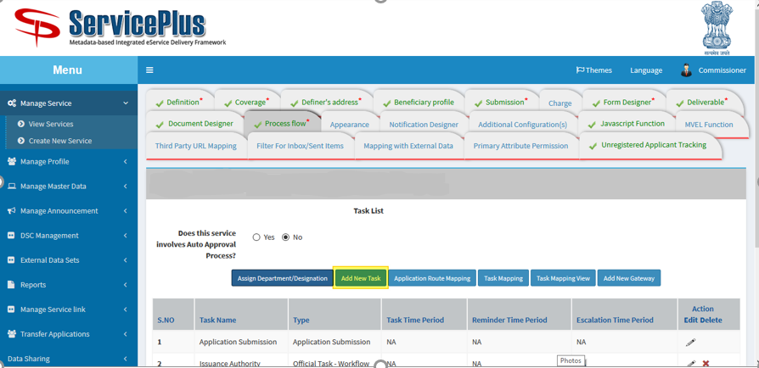

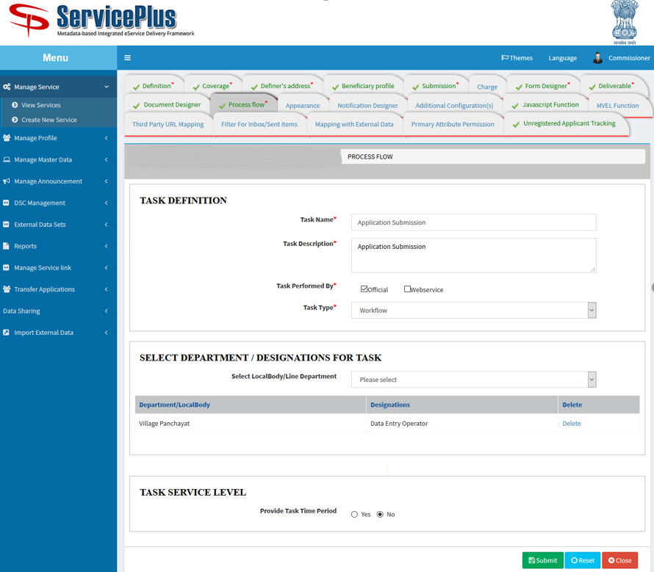

1. **JAVA SCRIPT FUNCTION: TO MAKE FORM DYNAMIC HERE JS FUNCTION CAN BE ADDED.**

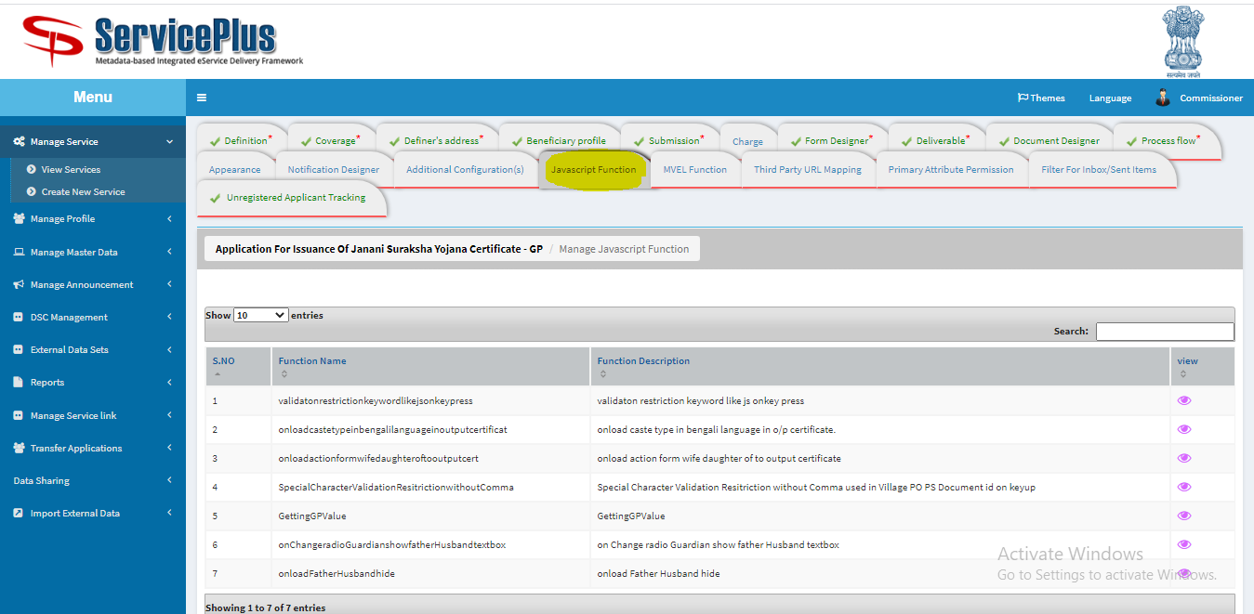

**JS in view mode**

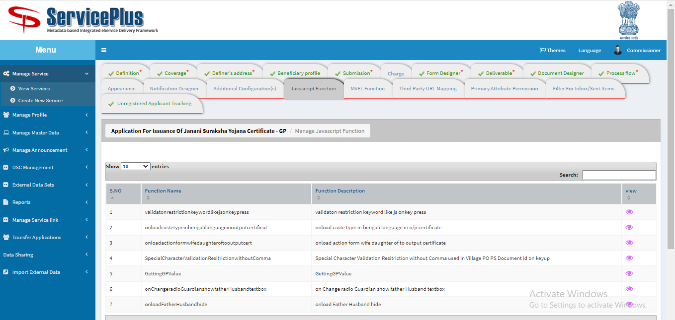

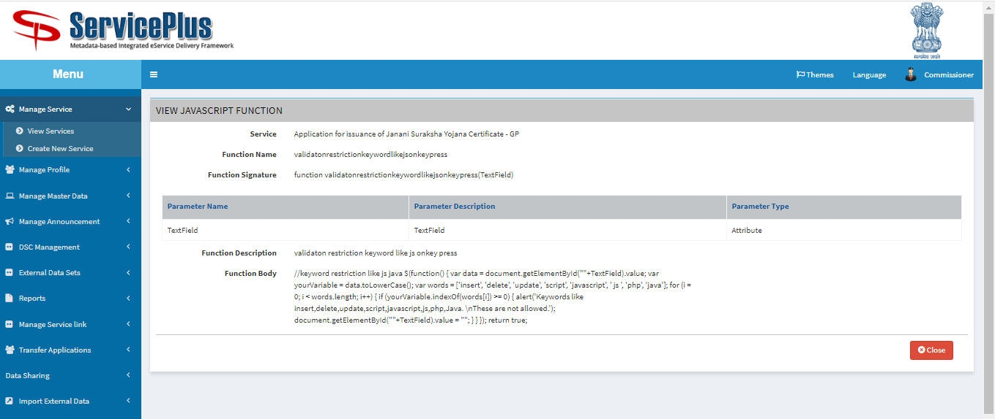

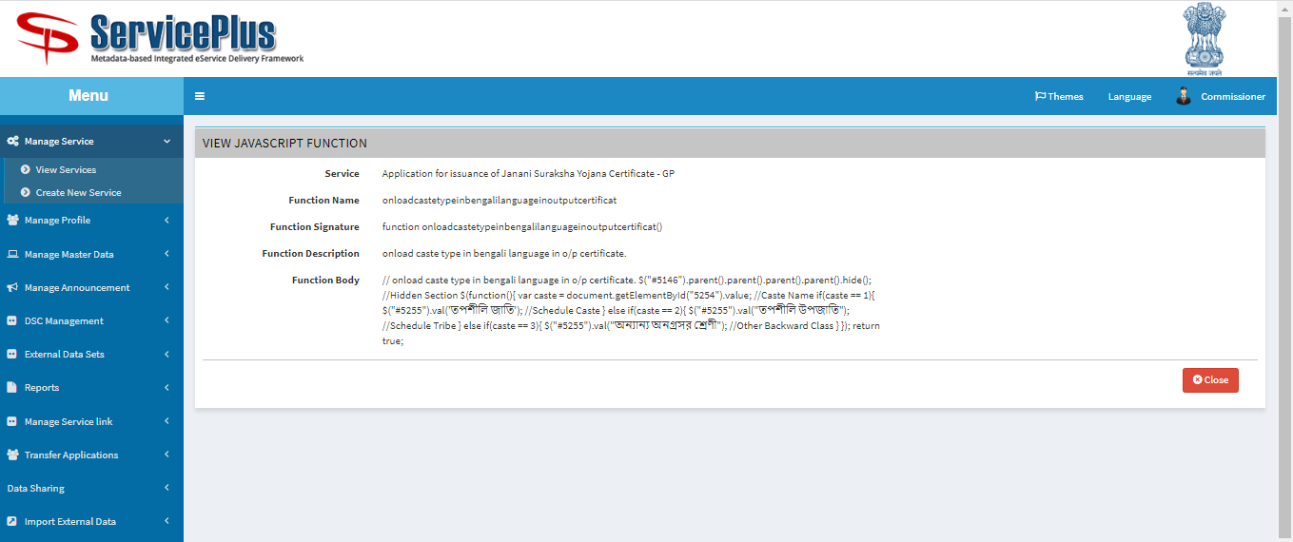

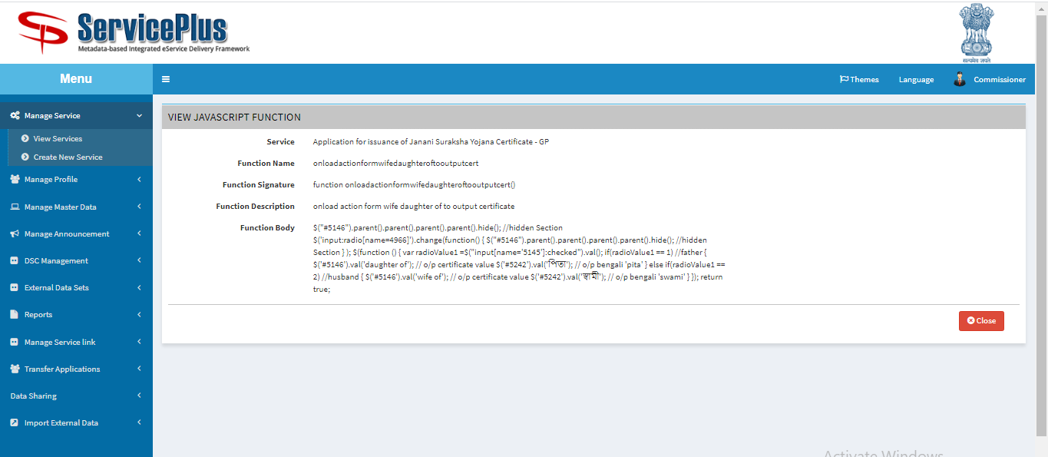

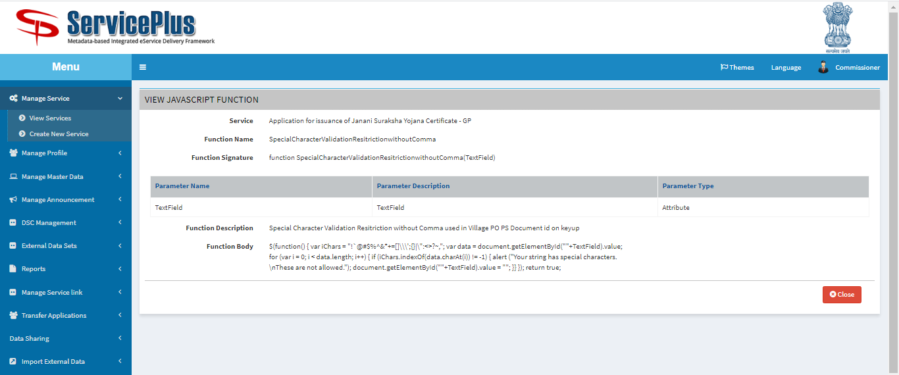

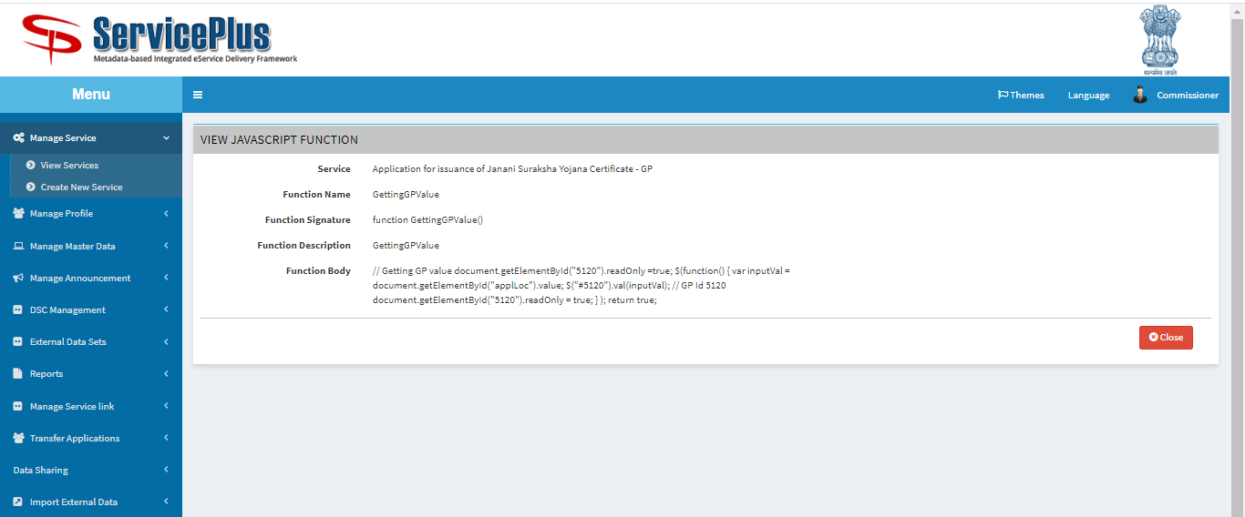

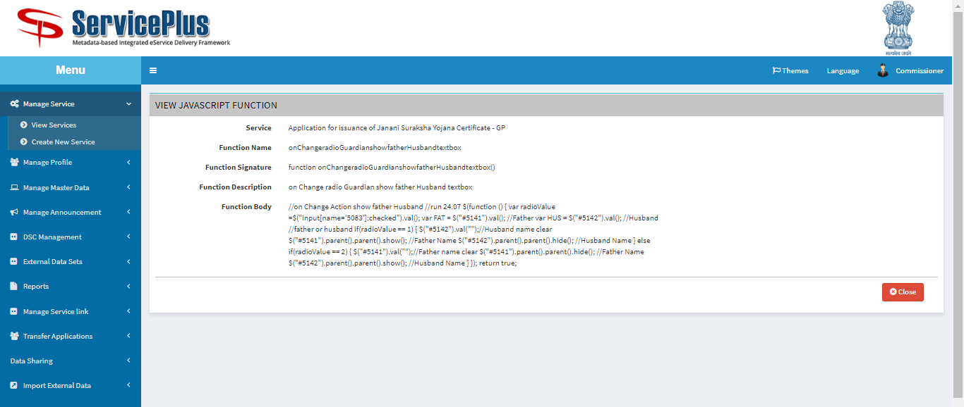

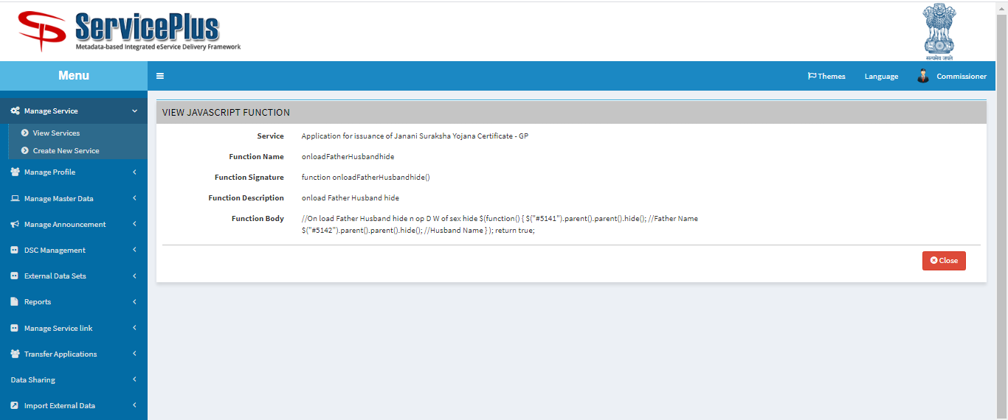

1. **UNREGISTRED TRACKING**

